Solving Systems of Equations by Graphing
Solve each system by graphing.
- $\left\{ \begin{aligned}&y=-\frac{5}{3}x+3 \\ &y=\frac{1}{3}x-3\end{aligned}\right.$
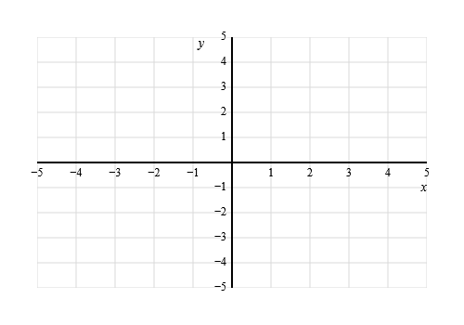
- $\left\{ \begin{aligned}&y=4x+3 \\ &y=-x-2\end{aligned}\right.$
- $\left\{ \begin{aligned}&y=-\frac{1}{2}x-1 \\ &y=\frac{1}{4}x-4\end{aligned}\right.$
- $\left\{ \begin{aligned}&y=-1 \\ &y=-\frac{5}{2}x+4\end{aligned}\right.$
- $\left\{ \begin{aligned}&y=3x-4 \\ &y=-\frac{1}{2}x+3\end{aligned}\right.$
- $\left\{ \begin{aligned}&y=-2x+2 \\ &y=-2x-2\end{aligned}\right.$
- $\left\{ \begin{aligned}&y=-\frac{1}{2}x-2 \\ &y=-\frac{3}{2}x+2\end{aligned}\right.$
- $\left\{ \begin{aligned}&y=\frac{1}{3}x-3 \\ &y=-x+1\end{aligned}\right.$

Answer Key
- $\left\{ \begin{aligned}&y=-\frac{5}{3}x+3 \\ &y=\frac{1}{3}x-3\end{aligned}\right.$
- 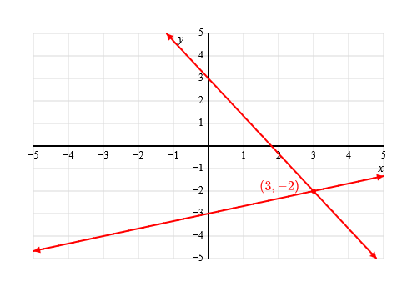
- $\left\{ \begin{aligned}&y=4x+3 \\ &y=-x-2\end{aligned}\right.$
- 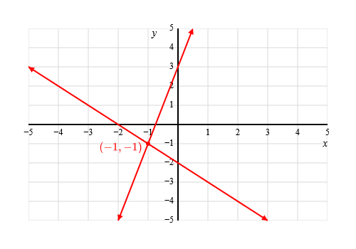
- $\left\{ \begin{aligned}&y=-\frac{1}{2}x-1 \\ &y=\frac{1}{4}x-4\end{aligned}\right.$
- 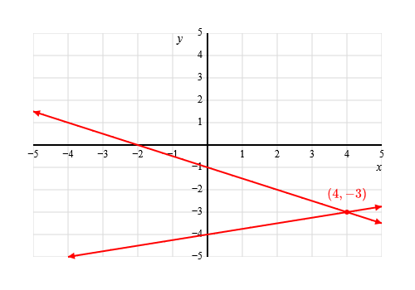
- $\left\{ \begin{aligned}&y=-1 \\ &y=-\frac{5}{2}x+4\end{aligned}\right.$
- 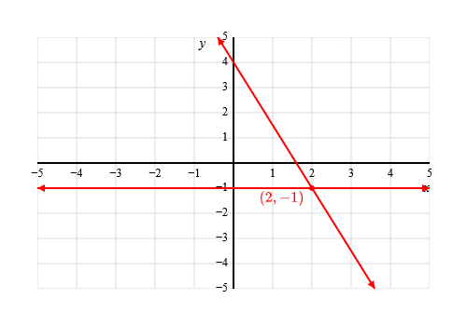
- $\left\{ \begin{aligned}&y=3x-4 \\ &y=-\frac{1}{2}x+3\end{aligned}\right.$
- 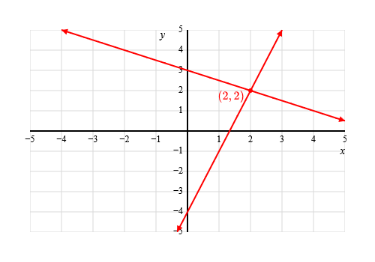
- $\left\{ \begin{aligned}&y=-2x+2 \\ &y=-2x-2\end{aligned}\right.$
- 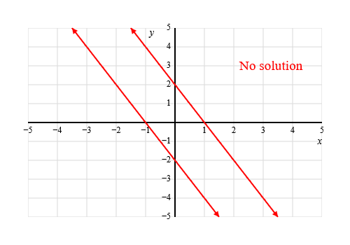
- $\left\{ \begin{aligned}&y=-\frac{1}{2}x-2 \\ &y=-\frac{3}{2}x+2\end{aligned}\right.$
- 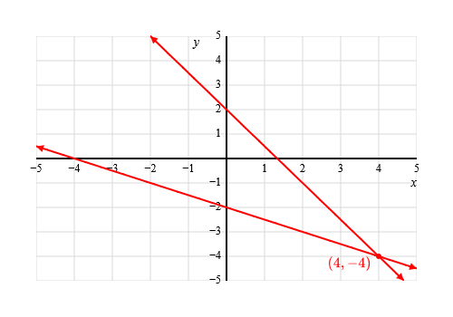
- $\left\{ \begin{aligned}&y=\frac{1}{3}x-3 \\ &y=-x+1\end{aligned}\right.$
- 