Paragraph Structure
Crafting an effective paragraph is one of the most fundamental skills in college writing. While paragraphs can look extremely different depending on the context, this guide provides some general tips for building a strong foundation. Once you have mastered the basics, you can try any number of creative variations. Just remember to follow any specific instructor requirements!
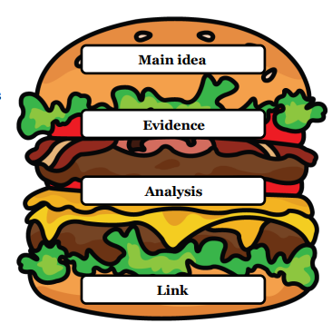
We like the “MEAL” approach (coined by Duke University) because (1) a paragraph should be filling and satisfying, and (2) who doesn’t love a good food mnemonic to help bridge the familiar and unfamiliar? The acronym “MEAL” describes the four main elements of a paragraph in order from beginning to end.

Main Idea:
This is the paragraph’s central focus, and it typically (but not always) appears in the first sentence, which is often referred
to as the “topic sentence.” This communicates the paragraph’s message and lets the reader know what to expect. In academic writing, the main idea is often argumentative and directly supports the thesis statement or primary claim.

Evidence:
This is where credible sources are typically referenced to support your main idea. This may involve direct quotations, paraphrases, summaries, or any other relevant pieces of information. If allowed by your instructor, it may also include personal experiences or anecdotes. The two most important things to remember are (1) to properly cite sources and (2) to back up your evidence with analysis.

Analysis:
This is where you take the evidence and explain how it applies to your main idea. How does it support, refute, or otherwise relate to the rest of the paragraph (and the paper at large)? One of the most common mistakes is providing evidence without proper analysis, so be sure to clarify why the evidence is there and what you interpret it to mean.

Link to Larger Claim:
This is the paragraph’s closing, and it typically consists of one or two concluding sentences that wrap up the paragraph and connect back to the primary claim. By the end, the reader should understand how the paragraph fits within the larger paper. They should not be left wondering about the paragraph’s main message or why it was included. The link may also help transition to the next paragraph.
PARAGRAPH EXAMPLE

MAIN IDEA EVIDENCE ANALYSIS LINK

The growing squirrel population in Minneapolis has led to a safety crisis where drivers are at risk of serious injury resulting from squirrels, and legislators are not providing funding to solve this safety crisis. According to Nguyen, a lead squirrel researcher at Minnesota College, “Last year in Minneapolis, there were over 4,000 reported motor vehicle accidents involving squirrel interference, but there has not been an increase in funding to solve the problem.” Evidently, squirrel-related car accidents are rampant (averaging almost a dozen per day), but the city has not taken the problem seriously, ignoring the experts to instead fund other projects around the city. One city council aid reported, “Sitting in on meetings, I have witnessed officials laughing at the experts who are begging for more funding to find effective solutions to reduce the population” (Lee). This kind of disregard for the safety of Minnesotans is unacceptable, and it shows a systemic issue where politicians are misusing their power and ignoring the needs of the public. The public needs to ask more from their legislators and hold them accountable for poor decision making, especially when they have been given clear evidence that they need to act quickly. The squirrel crisis in Minneapolis is endangering lives, and even if public officials are not moving to fix the problem, the squirrel population must be controlled for the safety of drivers in the metro area.

Adapted from the Duke Thompson Writing Program website: https://twp.duke.edu/sites/twp.duke.edu/files/file-attachments/meal-plan.original.pdf

